**Task No. 1:** Create a CRUD windows form application for students data using “One procedure for all CRUD operations” (use IF Else concept ).

**Solution:**

CREATE PROCEDURE ManageData

@name varchar(255),

@age int,

@image image,

@gender varchar(50),

@contact int,

@id int,

@operation varchar(10)

AS

BEGIN

IF @operation = 'INSERT'

BEGIN

INSERT INTO EmpDetails (name, age, gender, contact,picture)

VALUES (@name, @age, @gender, @contact,@image)

END

ELSE IF @operation = 'UPDATE'

BEGIN

UPDATE EmpDetails

SET name = @name, age = @age, gender = @gender, contact = @contact,picture=@image

WHERE ID = @id

END

ELSE IF @operation = 'DELETE'

BEGIN

DELETE FROM EmpDetails

WHERE ID = @id

END

END

---------------------------------------------------------------------------------------------

using System;

using System.ComponentModel;

using System.Configuration;

using System.Data;

using System.Data.SqlClient;

using System.Drawing;

using System.IO;

using System.Windows.Forms;

namespace CRUD{

public partial class EmpDetailsForm : For{

public EmpDetailsForm(){

InitializeComponent();

BindGridView();

pictureBox1.Image = Properties.Resources.OIP;

cmbgender.SelectedIndex = 0;}

string cs = ConfigurationManager.ConnectionStrings["dbcs"].ConnectionString;

void BindGridView(){

SqlConnection con = new SqlConnection(cs);

string query = "select * from EmpDetails ";

SqlDataAdapter sda = new SqlDataAdapter(query, con);

DataTable data = new DataTable();

sda.Fill(data);

dataGridView1.DataSource = data;

DataGridViewImageColumn dgv = new DataGridViewImageColumn();

dgv = (DataGridViewImageColumn)dataGridView1.Columns[5];

dgv.ImageLayout = DataGridViewImageCellLayout.Stretch;

dataGridView1.RowTemplate.Height = 50;}

public void FillGrid(string searchtext) {

int n;

bool isNumeric = int.TryParse(txtsearch.Text, out n);

string query = "";

SqlConnection con = new SqlConnection(cs);

try{

query = string.Empty;

if (isNumeric == false){

if (string.IsNullOrEmpty(searchtext.Trim())){

query = "select * from empdetails";}

else{

query = "select id, name,age,gender,contact,picture from Empdetails where (name+ ' ' +gender) like'%" + searchtext.Trim() + "%'";}}

if (isNumeric){

if (string.IsNullOrEmpty(searchtext.Trim())){

query = "select * from empdetails";}

else{

query = "select id, name,age,gender,contact,picture from Empdetails where (id+ ' ' +age+' '+contact) like'%" + searchtext.Trim() + "%'";}}

SqlDataAdapter sda = new SqlDataAdapter(query, con);

DataTable data = new DataTable();

sda.Fill(data);

dataGridView1.DataSource = data;}

catch{

MessageBox.Show("Some Issue Occur ", "Error", MessageBoxButtons.OK, MessageBoxIcon.Error);}}

private void btninsert_Click(object sender, EventArgs e){

if (cmbgender.SelectedIndex == 0){

errorProvider1.SetError(this.cmbgender, "Please Select Gender !");

cmbgender.Focus();

return;}

SqlConnection con = new SqlConnection(cs);

string query = "ManageData @name,@age,@pic,@gender,@contact,@id,@operation";

SqlCommand cmd = new SqlCommand(query, con);

cmd.Parameters.AddWithValue("@name", txtname.Text);

cmd.Parameters.AddWithValue("@age", txtage.Text);

cmd.Parameters.AddWithValue("@gender", cmbgender.Text);

cmd.Parameters.AddWithValue("@contact", txtcontact.Text);

cmd.Parameters.AddWithValue("@pic", SavePhoto());

cmd.Parameters.AddWithValue("@operation", "Insert");

cmd.Parameters.AddWithValue("@id", Convert.ToInt32(txtID.Text));

con.Open();

int a = cmd.ExecuteNonQuery();

if (a > 0){

MessageBox.Show("Inserted Data Successfully", "Success", MessageBoxButtons.OK, MessageBoxIcon.Information);

BindGridView();

clearControls();}

else{

MessageBox.Show("Insertion Failed", "Failed", MessageBoxButtons.OK, MessageBoxIcon.Error);}

con.Close();}

void clearControls({

txtID.Text = string.Empty;

txtname.Text = string.Empty;

txtcontact.Text = string.Empty;

txtage.Text = string.Empty;

cmbgender.SelectedIndex = 0;

pictureBox1.Image = Properties.Resources.OIP;}

private byte[] SavePhoto(){

MemoryStream ms = new MemoryStream();

pictureBox1.Image.Save(ms, pictureBox1.Image.RawFormat);

return ms.GetBuffer();}

private Image GetPhoto(byte[] img){

MemoryStream ms = new MemoryStream(img);

return Image.FromStream(ms);}

private void UploadImage_Click(object sender, EventArgs e){

OpenFileDialog open = new OpenFileDialog();

open.Title = "Upload Image";

open.Filter = "Image Files(*.jpg; *.jpeg; *.gif; *.bmp)|*.jpg; *.jpeg; *.gif; *.bmp|All files (*.*)|*.*";

if (open.ShowDialog() == DialogResult.OK){

pictureBox1.Image = new Bitmap(open.FileName);}}

private void btndelete_Click(object sender, EventArgs e){

SqlConnection con = new SqlConnection(cs);

string query = "ManageData @name,@age,@pic,@gender,@contact,@id,@operation";

SqlCommand cmd = new SqlCommand(query, con);

cmd.Parameters.AddWithValue("@name", txtname.Text);

cmd.Parameters.AddWithValue("@age", txtage.Text);

cmd.Parameters.AddWithValue("@gender", cmbgender.Text);

cmd.Parameters.AddWithValue("@contact", txtcontact.Text);

cmd.Parameters.AddWithValue("@pic", SavePhoto());

cmd.Parameters.AddWithValue("@operation", "Delete");

cmd.Parameters.AddWithValue("@id", Convert.ToInt32(txtID.Text));

con.Open();

int a = cmd.ExecuteNonQuery();

if (a > 0){

MessageBox.Show("Deleted Data Successfully", "Success", MessageBoxButtons.OK, MessageBoxIcon.Information);

BindGridView();

clearControls();}

else{

MessageBox.Show("Deletion Failed Failed", "Failed", MessageBoxButtons.OK, MessageBoxIcon.Error);}

con.Close();}

private void btnupdate_Click(object sender, EventArgs ){

if (cmbgender.SelectedIndex == 0){

errorProvider1.SetError(this.cmbgender, "Please Select Gender !");

cmbgender.Focus();

return;}

SqlConnection con = new SqlConnection(cs);

string query = "ManageData @name,@age,@pic,@gender,@contact,@id,@operation";

SqlCommand cmd = new SqlCommand(query, con);

cmd.Parameters.AddWithValue("@name", txtname.Text);

cmd.Parameters.AddWithValue("@age", txtage.Text);

cmd.Parameters.AddWithValue("@gender", cmbgender.Text);

cmd.Parameters.AddWithValue("@contact", txtcontact.Text);

cmd.Parameters.AddWithValue("@pic", SavePhoto());

cmd.Parameters.AddWithValue("@operation", "Update");

cmd.Parameters.AddWithValue("@id", Convert.ToInt32(txtID.Text));

con.Open();

int a = cmd.ExecuteNonQuery();

if (a > 0){

MessageBox.Show("Update Data Successfully", "Success", MessageBoxButtons.OK, MessageBoxIcon.Information);

BindGridView();

clearControls();}else{

MessageBox.Show("Updation Failed", "Failed", MessageBoxButtons.OK, MessageBoxIcon.Error);}

con.Close();}

private void dataGridView1_MouseDoubleClick_1(object sender, MouseEventArgs e){ if (dataGridView1.Rows.Count > 0){

txtID.Text = dataGridView1.SelectedRows[0].Cells[0].Value.ToString();

txtname.Text = dataGridView1.SelectedRows[0].Cells[1].Value.ToString();

txtage.Text = dataGridView1.SelectedRows[0].Cells[2].Value.ToString();

cmbgender.Text = dataGridView1.SelectedRows[0].Cells[3].Value.ToString();

txtcontact.Text = dataGridView1.SelectedRows[0].Cells[4].Value.ToString();

pictureBox1.Image = GetPhoto((byte[])dataGridView1.SelectedRows[0].Cells[5].Value);}}

private void searchtext_TextChanged(object sender, EventArgs e){

FillGrid(txtsearch.Text.Trim()); }}}

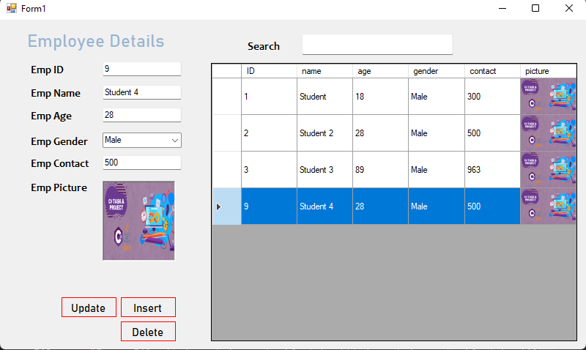**Output:**